**ASSIGNMENT (25.06.24)**

**Median of Medians**

1. To Implement the Median of Medians algorithm ensures that you handle the worst-case time complexity efficiently while finding the k-th smallest element in an unsorted array.

arr = [12, 3, 5, 7, 19] k = 2 Expected Output:5

arr = [12, 3, 5, 7, 4, 19, 26] k = 3 Expected Output:5

arr = [1, 2, 3, 4, 5, 6, 7, 8, 9, 10] k = 6 Expected Output:6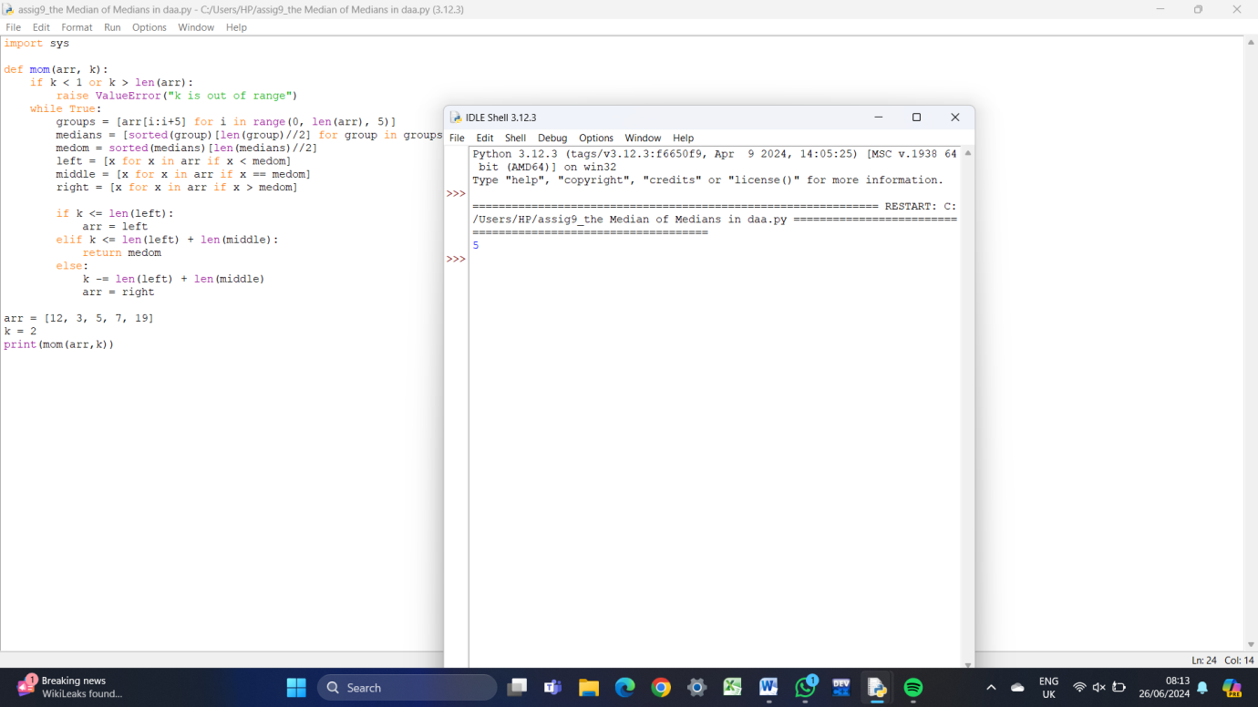

1. To Implement a function median_of_medians(arr, k) that takes an unsorted array arr and an integer k, and returns the k-th smallest element in the array.

arr = [1, 2, 3, 4, 5, 6, 7, 8, 9, 10] k = 6

arr = [23, 17, 31, 44, 55, 21, 20, 18, 19, 27] k = 5

Output: An integer representing the k-th smallest element in the array. 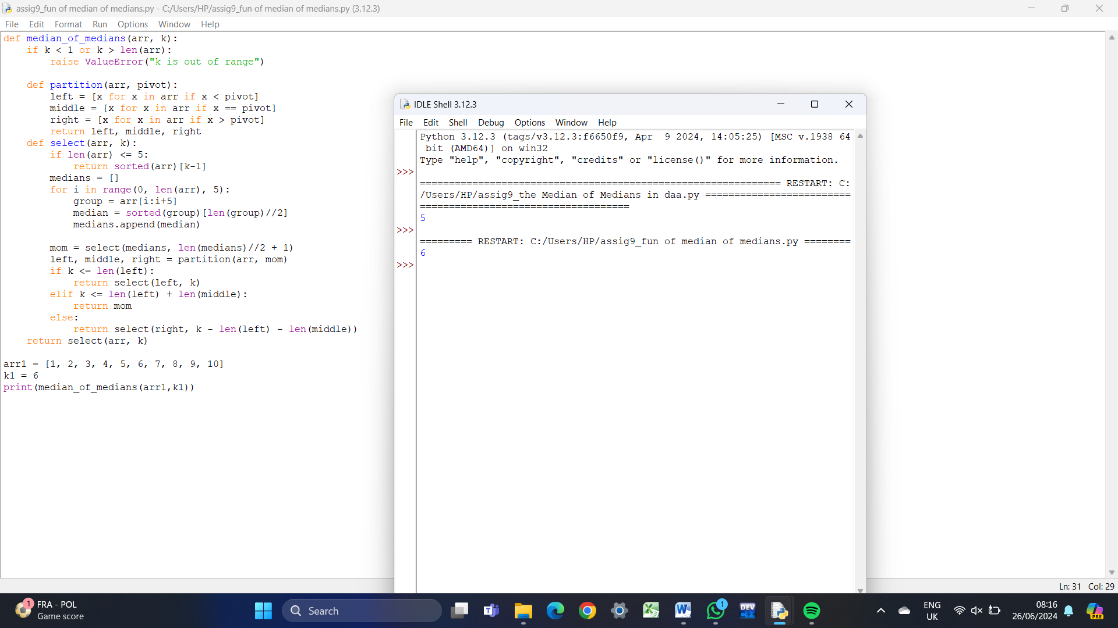

**Closest Pair of Points(Divide and Conquer)**

1. Given an array of points where points[i] = [xi, yi] represents a

point on the X-Y plane and an integer k, return the k closest

points to the origin (0, 0).

1. Input : points = [[1,3],[-2,2],[5,8],[0,1]],k=2

Output:[[-2, 2], [0, 1]]

1. Input: points = [[1, 3], [-2, 2]], k = 1

Output: [[-2, 2]]

1. Input: points = [[3, 3], [5, -1], [-2, 4]], k = 2

Output: [[3, 3], [-2, 4]] 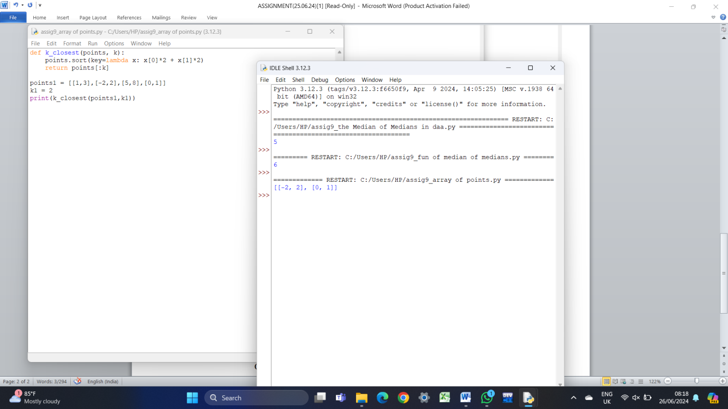

1. Given four lists A, B, C, D of integer values, Write a program to

compute how many tuples (i, j, k, l) there are such that

A[i] + B[j] + C[k] + D[l] is zero.

1. Input: A = [1, 2], B = [-2, -1], C = [-1, 2], D = [0, 2]

Output: 2

1. Input: A = [0], B = [0], C = [0], D = [0]

Output: 1 